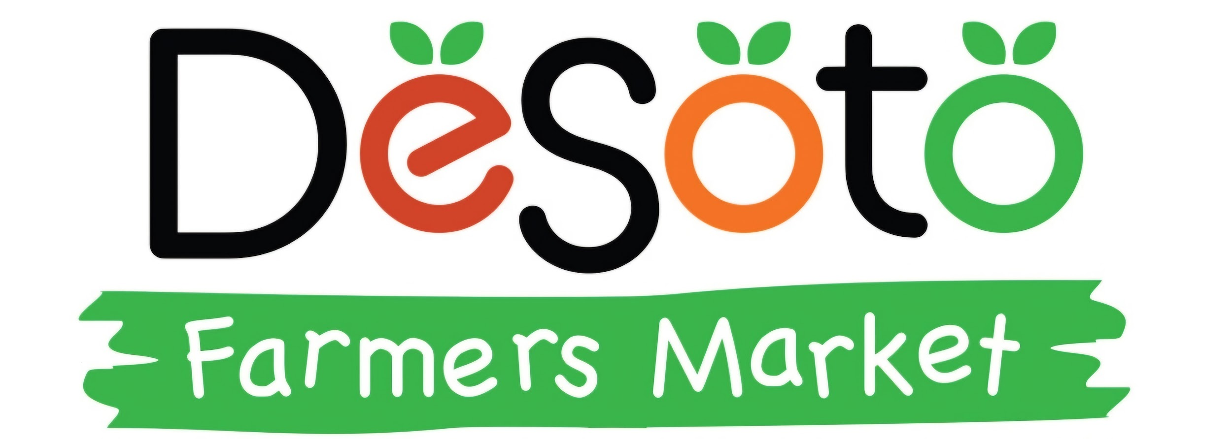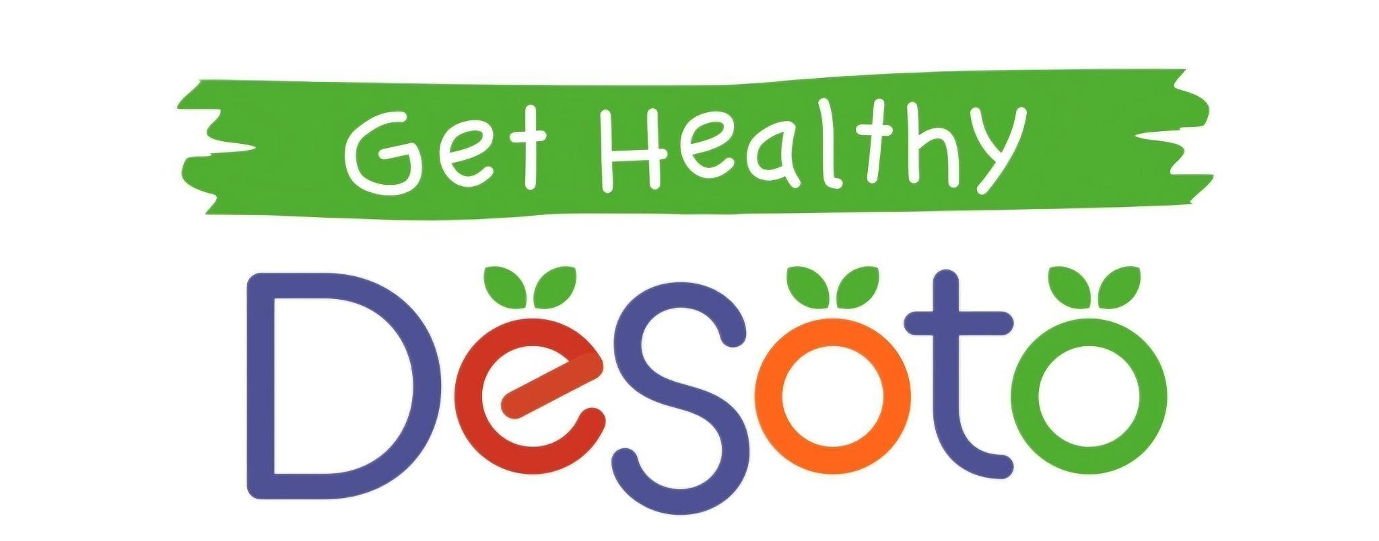

520 North Main Street | DeSoto, Missouri 63020 Market Hours: Saturday 8:00 AM-12 Noon

314-550-8463 [market@gethealthydesoto.org](mailto:market@gethealthydesoto.org)

**2025 Volunteer Application**

Name:_____________________________ Phone #:_________________________________

Address:______________________________________ E-mail:_________________________

**Volunteer Opportunities:**

(Sign-ups for specific dates/times will be sent after application is submitted)

□Trivia Night Jan. 25, 2025

□Winter Flakes Feb. 22, 2025

□Craft Fair/Plant Sale April 19, 2025

□Tractor Parade April 26, 2025

□Market Open/Close: Saturdays (7am-9am)/Saturdays (10:30am-12:30pm)

□Market Pop Club Craft: Saturdays Shift 1 (7:45am-10am) Shift 2(10am-12:15am)

□Farm to Table: Fall - Date TBD

□Community Garden Work Day/Maintenance: Date and Time TBD

Committees

□De Soto Farmers Market (Meets Monthly - Information Table, Crafts, Classes, Work Days, Spring Craft Fair, Tractor Parade, Family Olympics, Market Quest Scavenger Hunt, Community Garden, Christmas Market, etc. )

□Farm to Table 2025 (approx. 5 meetings before Oct. 5th)

□Christmas Home Tour 2025 ( 6 meetings april-nov)

□Trivia Night 2026 (approx. 4 meetings June-Sept)

□Winter Flakes 10k/5k Race 2026 (approx. 5 meetings Aug-Dec.)

*Waiver of Liability*: In consideration of your accepting this application, I the undersigned, intending to be legally bound, hereby, for myself, my heirs, executors and demonstrators, waive and release any and all rights and claims for damages I may have against the Get Healthy DeSoto, its organizers, their sponsors, their representatives, successors, and assignees for any and all injuries suffered by myself or my guests in the event. Further, I hereby grant full permission to the event organizers and/or agents authorized by them, to use any photographs, videotapes, recordings or any other record of the event for legal purposes. I agree to abide by the rules and regulations of DeSoto Farmers’ Market, a project of Get Healthy DeSoto.

Signature:____________________________________ Date:_________________________