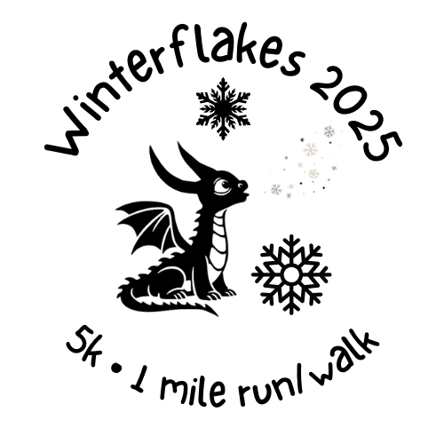

Winter Flakes 5K\1 Mile Run & Walk

______________________________________________________________________________________________________________________________

Saturday, February 22, 2025 @ 8 AM

DeSoto Farmers’ Market | 520 N. Main St. | De Soto, MO 63020

| ***Proceeds of this race will enable Get Healthy De Soto, whose mission is to promote a healthy lifestyle, to hire a director, to fund efforts to improve various community areas & activities around De Soto, Missouri. All abilities and speeds are encouraged to come! Strollers are welcome!*** |
| --- |

| Entry Fees  **On or before 2/5/2025**  5K - $25 per person  1 mile - $15 per person  Kids Under 12 Any Race - $10 per person  *Participants registered on or before 2/18 are guaranteed a unisex, long-sleeved t-shirt.* | Packet Pickup  Packets are available for pickup on 2/22/2025 beginning at 6:30 AM the day of race. Race day registration ends at 7:15 AM. |
| --- | --- |
| Race Divisions  Awards will be presented to the top two male and female finishers in each division and best overall male and female finishers of the 5K race. All kids 12 and under will receive a participation ribbon. Award ceremony follows the race. |
| **After 2/5/2025**  5K - $30 per person  1 mile - $20 per person  Kids Under 12 Any Race - $15 per person | 5K Divisions  15 & under, 16-19, 20-29, 30-39, 40-49, 50-59, 60-69, 70+ |

**Registration is also available at** [**https://gethealthydesoto.org/programs-activities/winter-flakes/**](https://gethealthydesoto.org/programs-activities/winter-flakes/)

Questions? Contact winterflakes@gethealthydesoto.org. In the event of inclement weather, please check the Winter Flakes Facebook page or call 314-550-8463 the morning of the race. Only under extreme weather conditions (i.e., ice) will the event be rescheduled. No refunds will be granted. Make checks payable to “Get Healthy DeSoto.” Mail completed forms to: Winter Flakes Race, 520 N. Main St. DeSoto, MO 63020.

| Race entered: |  |  | _____ | 5K | _____ | 1-mile |  |
| --- | --- | --- | --- | --- | --- | --- | --- |
| ________________________________ | | |  | ______________________________ | | |  |
| Last Name |  |  |  | First Name |  |  |  |
| __________________________________________________________________________________________________ | | | | | | | |
| Street Address/City/State/Zip | | | |  |  |  |  |
| ____________ |  |  | Male | Female |  |  |  |
| Date of Birth | |  | *circle one* | |  |  |  |
| ________________________________________ | | | |  | ________________________________ | | |
| Email Address | | |  |  | Phone Number | |  |
| Circle shirt size (unisex t-shirt) | | *Adult:* | Small | Medium | Large | X-Large | XX-Large |
| *Youth:* | Small | Medium | Large |  |  |

Waiver: I know that running a road race is a potentially hazardous activity. I should not enter unless I am medically able and properly trained. I assume all risks associated with running/walking this event. Having read this waiver and knowing these facts and in consideration of your accepting my entry fee, I, for myself, and anyone entitled to act on my behalf, waive and release Get Healthy De Soto Inc., and all sponsors, their representatives and successors, for all claims or liabilities of any kind arising out of my participation in this event.

| ___________________________________________ | _________________________ |
| --- | --- |
| Signature (Parent’s signature if under 18) | Date |